**Day3 LSP 18/7/24**

**1> vim— to create and edit while.cpp**

**2>make— to compile while.cpp into an executable while**

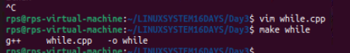

**3>./while— to show the output of the while program. It will run an infinite loop.**

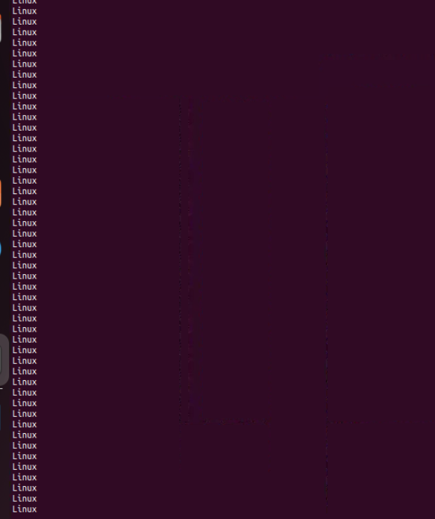

**htop cmd— it help us to check all the processes which are currently running. It is easy to use as it provide every information as graphical interface and better than ps command.**

**Steps to use htop**

**1> sudo apt install htop**

**2>htop– run cmd htop**

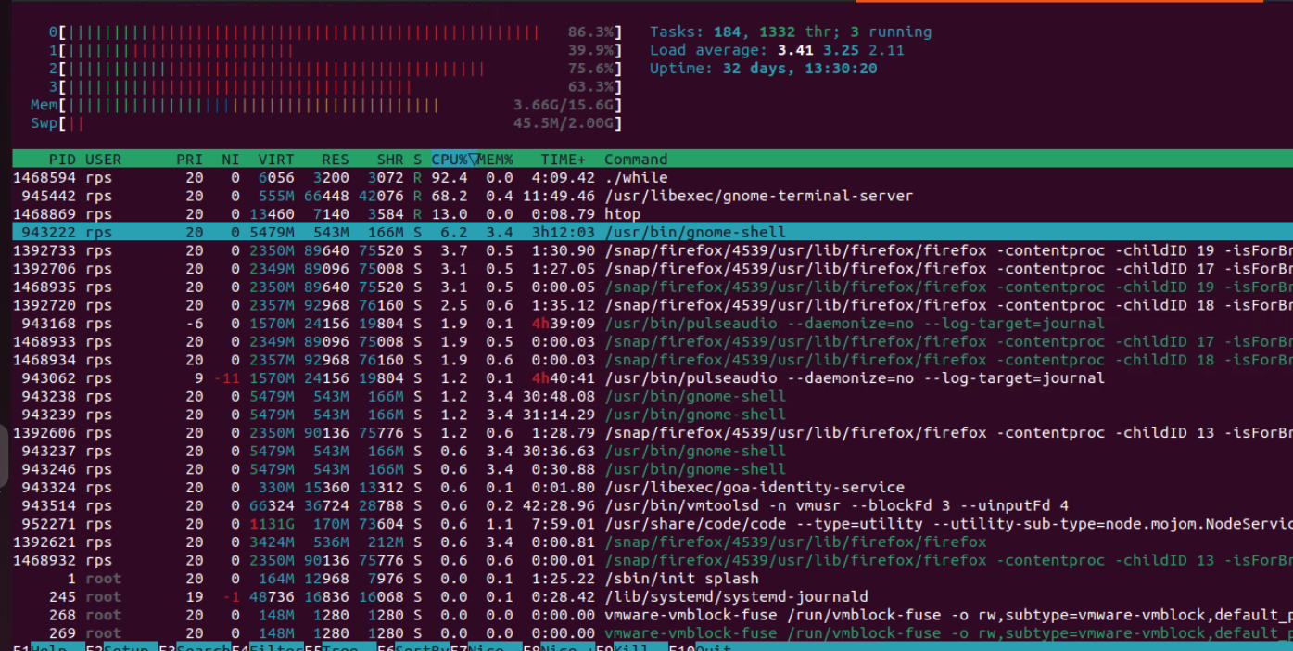

**It will show all your processes which are currently running with detailed info such as Pid, cpu memory usage — it will show how much memory is consumed by every program in the computer as live.**

**It helps us to kill any process which is currently running.**

**Kill cmd — it allow to stop the running process**

**If we want to kill any process**

**For example, while loop is running infinite time I want to kill that process . steps to perform that are as follows**

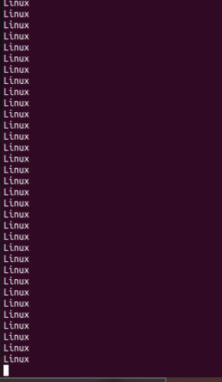

**To kill this process**

**1> run htop cmd - to check current process which are running.**

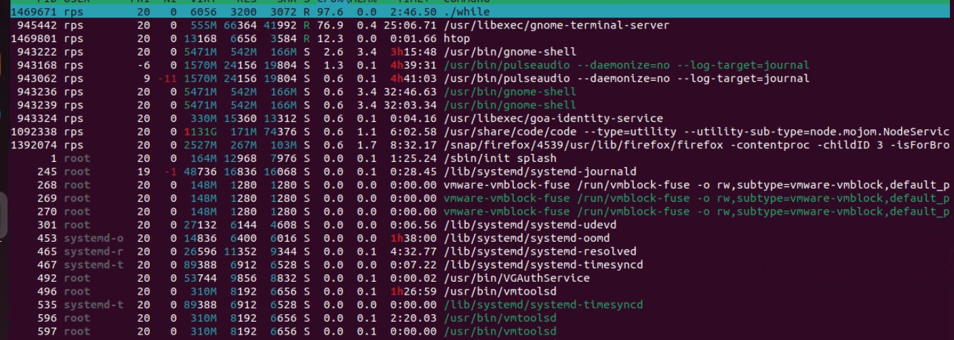

**Now select the process you want to kill using up or down arrow key and then press k**

**And hit enter. After pressing k, htop will display a list of signals that you can send to the process.**

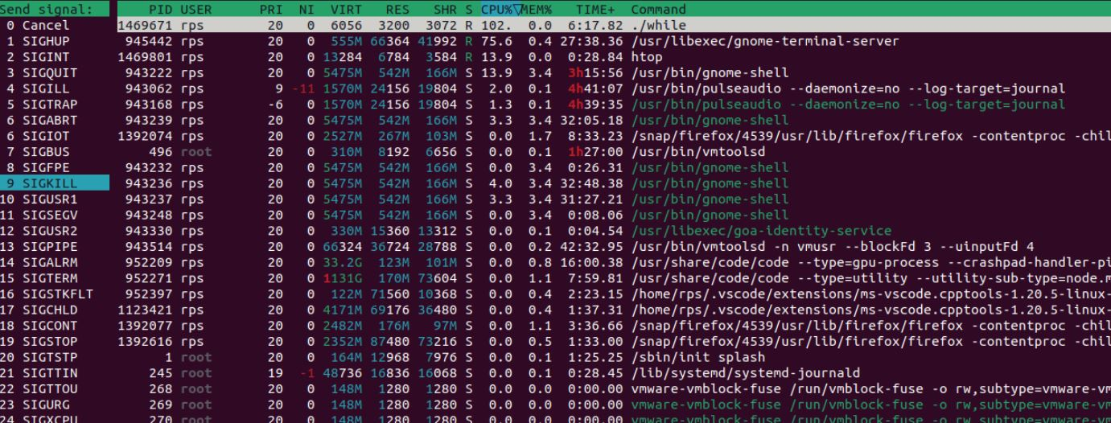

**Mostly used signal are SIGKILL (9) - it will forcefully kill the process.**

**SIGTERM(15)- it will gracefully kill the process.**

**After selecting hit enter Your process is killed.**

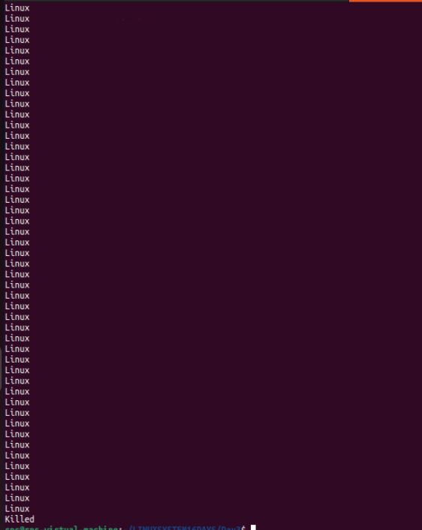

**Activity1— create sh file and print hello world**

**1> create sh file using vim then edit that file.**

**Vim hello.sh**

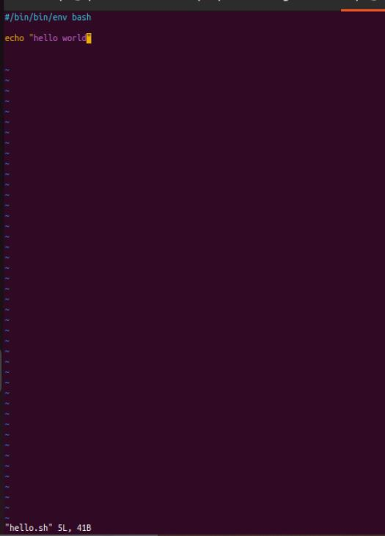

**2> To see output– use sh filename for eg sh hello.sh**



**3> to see content of file use cat hello.sh**



**Copy content of this file into another using cp hello.sh hello1.sh**

**Now do vim hello1.sh to edit the file**

**Then , see the output using sh hello1.sh**

**Now see the content using cat hello1.sh**

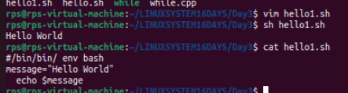

**Activity3 Now create another sh file and modify it**

**1> vim hello2.sh**

**2> sh hello2.sh**

**3>cat hello2.sh**

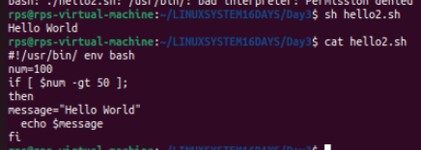

**File Search:**

**Write a command to find all files with the extension .txt in the /home directory and its subdirectories.**



**File Permissions:**

**Write a command to change the permissions of all files in the /var/log directory to 644.**



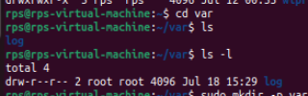

**Disk Usage:**

**Write a command to display the disk usage of all directories in the /home directory in a human-readable format.**



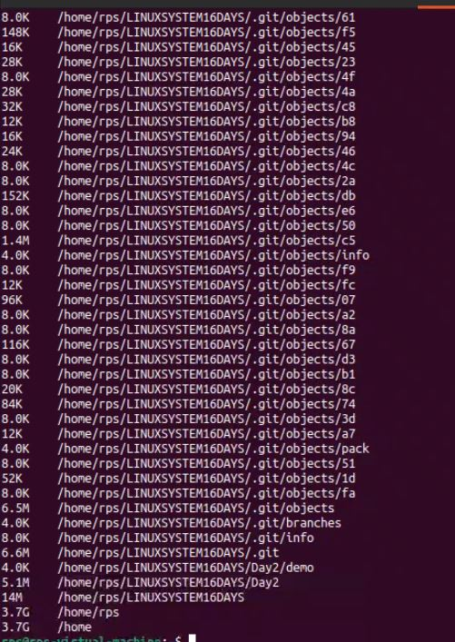

**Process Management:**

**Write a command to list all running processes that contain the name "apache" in their command line.**



**Text Processing:**

**Write a command to count the number of lines in a file named error.log.**

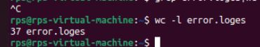

**Network Configuration:**

**Write a command to display the IP address of all network interfaces on the system.**



**Package Management:**

**Write a command to install a package named htop using the package manager.**

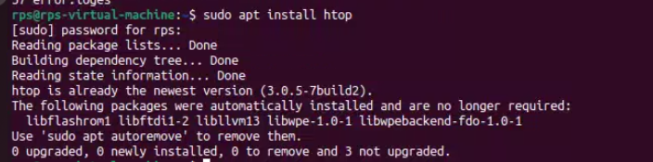

**User Management:**

**Write a command to add a new user named developer to the system.**



**File Compression:**

**Write a command to compress a directory named backup into a .tar.gz file.**

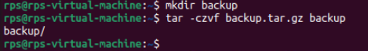

**System Monitoring:**

**Write a command to display real-time system resource usage, including CPU, memory, and disk I/O.**

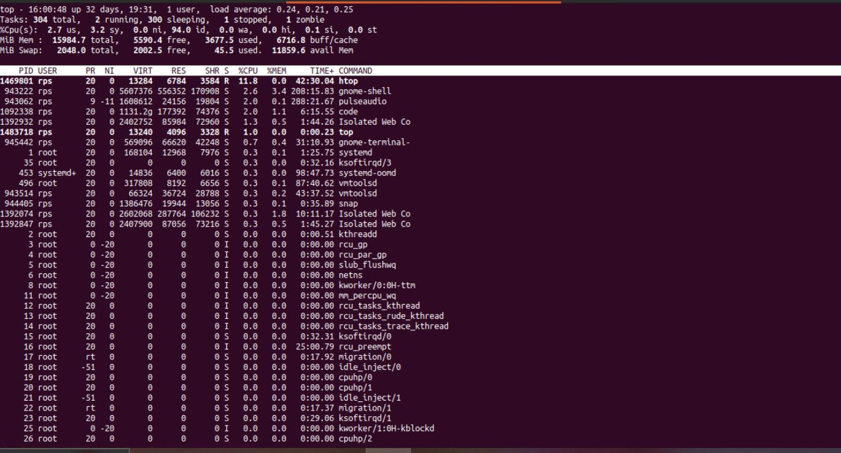

**Ps - It tells about current running processes.**

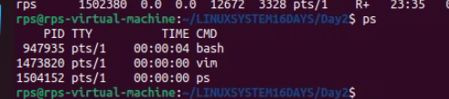

**PId- Process Id it will be unique**

**TTY- Terminal associated with processes.**

**-> Ps x- It shows all Type of processes .**

**R: Running or runnable (on run queue).**

**S: Sleeping (waiting for an event to complete).**

**D: Uninterruptible sleep (usually I/O).**

**T: Stopped by job control signal.**

**t: Stopped by debugger during the tracing.**

**Z: Zombie (terminated but not reaped by its parent).**

**X: Dead (should never be seen**

**-> ps aux – detailed information about all type of process whether they are in running mode or sleeping or background running with user.**

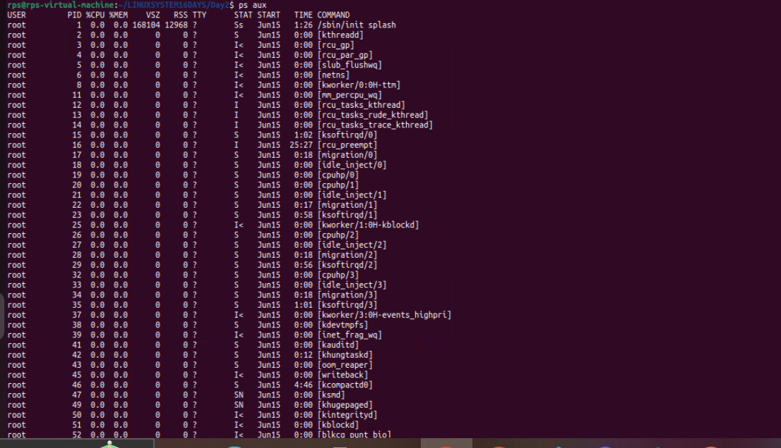

**Ques What is Process?**

**When we run any cmd or shell script process is created.**

**Types of process**

**1> foreground 2> background**

**Ex of foreground Ex of background**

**Pwd pwd &--------------it will denote it is background cmd**

**/xyz/home [1] 2194**

**After running output it will**

**Immediately exit.**

**EX OF BACKGROUND PROCESS**

